
Sample Study Guide
The Boy Who Cried Wolf

Overview
Silas is from a family of shepherds and has to do right by his mum and granddad as he reluctantly takes on the responsibility of watching their sheep up on the mountain over the winter. But he’s bored, lonely, and missing out on the fun of the annual knitting competition in town, so he cries - “Wolf!”
This is a beautiful wintery tale about a boy who learns that “nobody believes a liar, even when they’re telling the truth” and finds a place for himself (and his imagination) in his warm woolly community. Inspired by Aesop’s famous fable, a gifted ensemble of actor musicians play instruments and sing live as they embody all the delightful characters, including hilarious sheep and perhaps a scary wolf or two…
Vocabulary
Fable | A fable is a story that features animals, plants or forces of nature which are anthropomorphised (given human qualities). A fable always ends with a ‘moral’. This is the lesson that is intended to be learnt through reading the story.
Tellies | Telly is short for television
Wellies | A knee-length waterproof rubber or plastic boot that protects your feet from puddles and mud.
Slippers | A comfortable slip-on shoe that is worn indoors.
Piccalilli | Piccalilli is an English interpretation of South Asian pickles, a relish of chopped pickled vegetables and spices; regional recipes vary considerably. Picalilli is a relish which usually accompanies cheese or cured meats.

Background on Aesop
Most of our best-known fables are thought to have been written by a man called Aesop. The life of Aesop is a bit of a mystery. There is even some debate if Aesop was an actual person or just a name used by another writer. However, there have been mentions of Aesop in Greek history, which has allowed historians to piece together a biography (if it is true that he exists). Many of the stories about Aesop contain mythical interventions and legends.
Aesop is believed to have been alive from 620 to 560 BC. It was believed that he was a slave, but was given his freedom because of his literacy and storytelling. He is also described as having many physical deformities and a speech impediment that was healed by a deity. Aesop was said to have escaped punishment many times throughout his life, often standing up to his accusers and telling a story that showed the irony or the characteristics of those punishing him. His death is just as much of a mystery as his life. It is believed that he stole a gold or silver cup and was violently put to death by being thrown off a cliff.
Although Aesop is mentioned in Greek history, particularly by Greek historian Herodotus and Aristotle, many scholars do not believe that he actually existed. There is simply just not enough proof to confirm that he was alive.
Science Fact-file
Sheep
- Sheep live on farms and are kept in large groups called flocks. A female sheep is called a Ewe, a male sheep is called a Ram and a baby sheep is called a Lamb. Sheep are herbivores and they eat grass.
- We get many things from sheep, including wool. A sheep’s woolly coat is called a fleece. In the spring the sheep’s fleece is clipped off, this is called shearing. When the fleece has been sheared off, it has to be washed and combed. This is called carding. The fleece is then spun into yarn and this makes the wool. The wool is made into lots of things we can wear or use in our houses including warm jumpers!
- Sheep also give us meat, milk and cheese.
Wolves
- A wolf is a predatory animal. This means that they hunt for their food. They live in groups called packs and hunt together. Wolves are from the same family of animals that includes dogs, foxes and coyotes. Wolves prey on large hoofed animals such as deer, moose and bison.
- Wolves are native to North America, Canada, Asia, Europe and the Arctic. Their most common habitat is a forest.
- A baby wolf is known as a pup. Pups are born inside a den, which is a cave or a hole in the ground. Wolves usually have a litter of 4-6 pups at a time.
- Once they are adults, wolves reach the height of 27-31 inches on all fours. This is approximately the height of a toddler. The grey wolf weighs between 70-136 lbs, which is approximately the weight of a teenage girl.
- Wolves have very strong jaws, this helps them to eat meat. They can walk on their tip toes and they can reach a speed of up to 35 miles per hour, that is faster than a car driving around a town. Wolves also have a highly developed sense of smell and hearing.
- Wildlife experts say that wolves are endangered. This means that they are in danger of extinction. This is due to habitat destruction, the introduction of exotic species, water pollution, global warming and the over use of natural resources.
Social and Emotional Development
Truthfulness & Honesty
We human beings are very clever! From a very young age we quickly learn that telling lies and exaggerating can not only prevent us from being punished for something that we should not have done, but can also help us to get what we want. Just like Silas who cried wolf because he didn’t want to be a shepherd.
So what difference does it make if we tell a lie from time to time? The odd 'fib' once or twice a day .... a little exaggeration now and again .... blaming others occasionally .... can't do any harm surely? One big problem with being dishonest and exaggerating is that it is a very easy habit to start and continue but a very, very difficult habit to stop; and as we get older the consequences of being dishonest increase significantly. What were the consequences of Silas lying to his family and friends?
There are many reasons that we might tell a lie, exaggerate or make excuses. Here are a few for you to think about:
- avoiding punishment
- avoiding embarrassment
- avoiding conflict
- avoiding doing something that we do not want to do
- to get our own way or to get what we want
- to be accepted or liked
- to make ourselves feel equal to others
- not wanting to hurt others' feelings
- not wanting others to dislike us or think less of us.
Why do you think Silas told a lie?
It can take a lot of courage to tell the truth particularly when we fear consequences or some form of punishment. (It can also be difficult to hear others being honest about something that has happened particularly when we have been involved and would rather keep the truth hidden!) However, as we grow older and take on more responsibilities and commitments, it is very important that we stay aware of what we are saying and how it affects ourselves and others. It is equally important that we learn to admit our mistakes and take responsibility for the things that we have done (or maybe failed to do). It is very easy to blame others (or blame the situation) when things go wrong which can often mean that we are trying to cover up our shortcomings and weaknesses; hearing ourselves blaming others but then correcting ourselves or apologising is a big step towards living a more honest life.
Respect
You can have respect for someone, their feelings, their wishes or their rights. You can have respect for things other than humans or things that are not living.
We can’t expect to be respected unless we show respect. We don’t want people to be rude to us, ignore us, hurt us, not trust us, take our things, break or spoil things, mess up our special places or spoil our experiences. Do you think Silas showed respect to his family and the villages? Why?
We can show respect by caring, following rules, respecting ourselves, being reliable, being punctual, being polite, trusting, keeping our promises and being fair.
Self Awareness
Self awareness means knowing who you are and what feelings, thoughts and emotions influence your behaviour. This sounds very simple, but it takes a long time and a lot of thought to truly gain awareness of oneself. In order to know who you are, you have to know many things about yourself: not just facts, but your own character traits and personality. To be self-aware, you have to know the emotions you have and why you feel them. You also have to know why you behave in the ways you do, and why you might react to people or situations in a particular way. Another part of self-awareness is understanding what is important to you and what motivates you. What was Silas thinking and feeling before he told the lie? Do you think he was self-aware?
Nobody is born perfectly self-aware; everybody has to put a lot of work into discovering these things about themselves. You could argue that it takes a lifetime to achieve full self-awareness; it certainly is a useful skill throughout your life.
Decision Making
As we can see from the play, Silas made some bad decisions! Sometimes we make bad decisions when we don’t understand how we are feeling and we have not thought about the consequences. A consequence is a result of something and can be good or bad. Things to think about before making a decision:
- What will happen if I do this
- What will happen if I don’t do this
- Who will it affect if I do it/don’t do it?
- What will I need to do?
We can always find alternative choices to our decisions, what if I did this instead and what would happen then? What are some alternative choices Silas could have made?
Lots of different things can affect decision making. You might not be able to make good decisions if you are sad, angry, upset, tired, hurt or poorly. Why do you think Silas made the decision to lie?


We'd love to see your jumper, please send us your pictures to: hello@tutti-frutti.org.uk
Design a winning jumper

Every year Silas’s mother knits a jumper to enter into the Winter Jumper Competition - Silas asks her to knit the picture of an astronaut on his jumper because that is what he wants to be when he grows up.
What would you like to be when you grow up? An astronaut? A tightrope walker? A storyteller?
Can you design a jumper using the template below, with a picture on it showing what you’d like to be when you’re older?
You could either draw or paint your design or stick things on to make a picture. We would love to see the results!

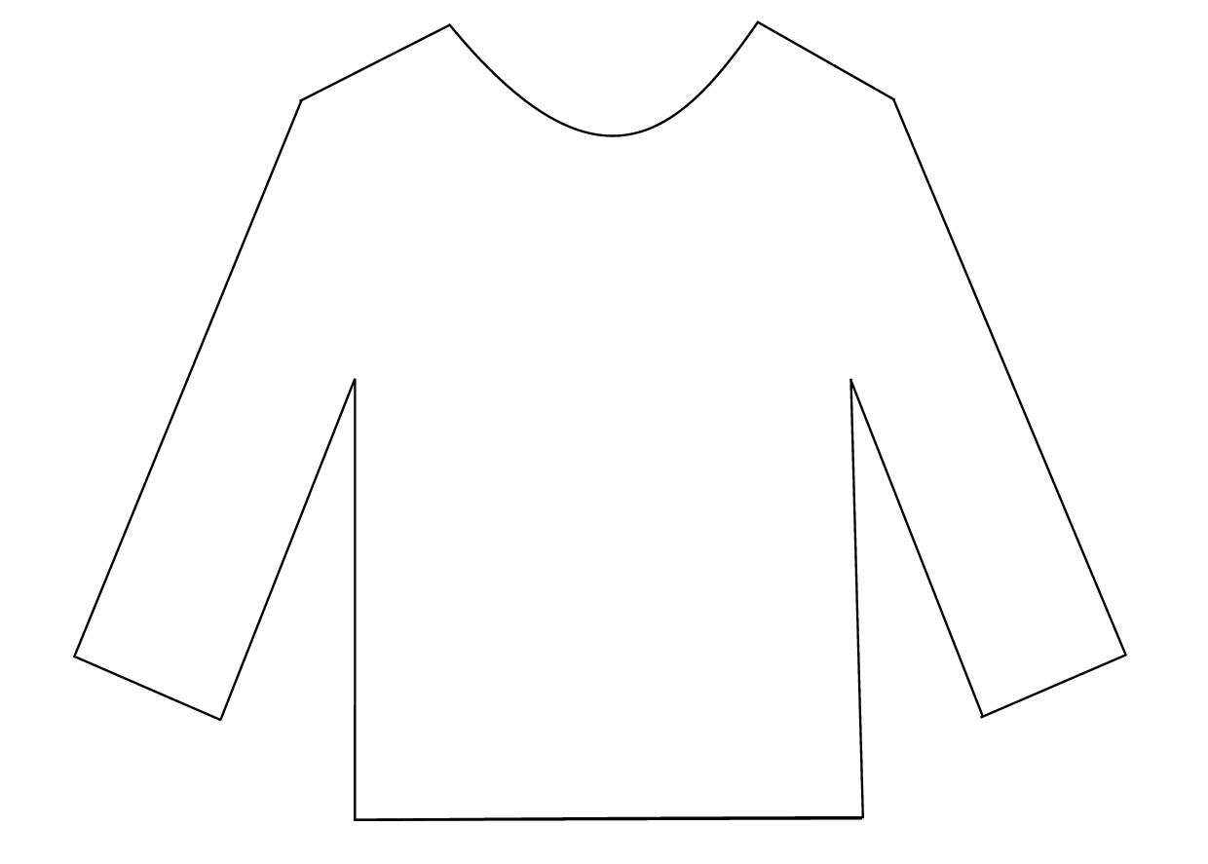

–––
Making snowy wool pictures

Silas’s feelings change throughout the story depending on what he is doing, who he is with and where he is.
Can you draw a line between things that happened to Silas in the story and how he felt? Can you think of a time when you had those feelings?

Silas’s Story
Feeling
Fear
Worry
Love
Bravery
Excitement
Boredom
Pleasure
Tiredness
Disappointment
Laziness
Event
Being with Mother
Winning the jumper competition
Facing the wolf
Not helping the family
Being on the mountain
Dancing at the party
Working
Watching the sheep
Grandfather being ill
Losing the jumper competition

–––
Making snowy wool pictures

In the story of The Boy Who Cried Wolf the villagers hold a winter knitting competition and have a party to light up the dark nights and take their minds off the wintry weather. Lots of people all over the world have winter festivals to cheer up the winter months.
Talk with the children about why we have winter celebrations. How many can they think of?

Winter Festivals

- What Winter Festivals/Festivals of Light do we all celebrate – Diwali/Christmas/ Hanukkah?
- How do we celebrate with our families/what do we do?
- How are they similar and how are the different?
- Ask the children what they would do if they held their own winter festival?
- How would they celebrate?

Why not make some Jam Jar Lanterns (see our other resources) or some snow decorations or winter bunting to light up the classroom?



–––
Making snowy wool pictures

Silas spends three winters up on the mountain. Ask the children what Silas might have seen when he was up on the mountain during the winter? What would his surroundings have been like, what would he have sat on, looked at?
From their ideas make a list as a whole class or in smaller groups (using words or pictures) which you can use to go on a scavenger hunt.
Take the class on a winter walk with your ‘scavenger list’ and see how many of the things on the list you can find outside. You can collect pinecones to bring back to the classroom, and photograph or ask the children to draw animal tracks.

Boy Wolf Winter Walk
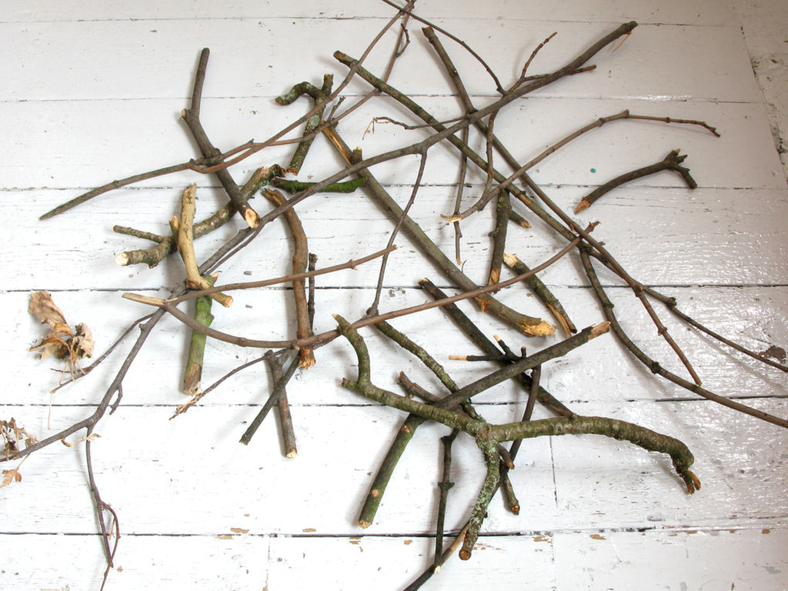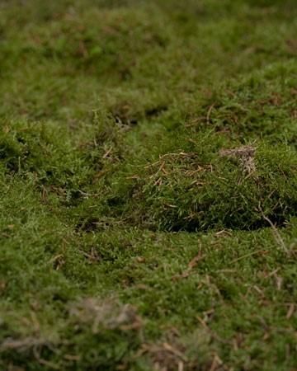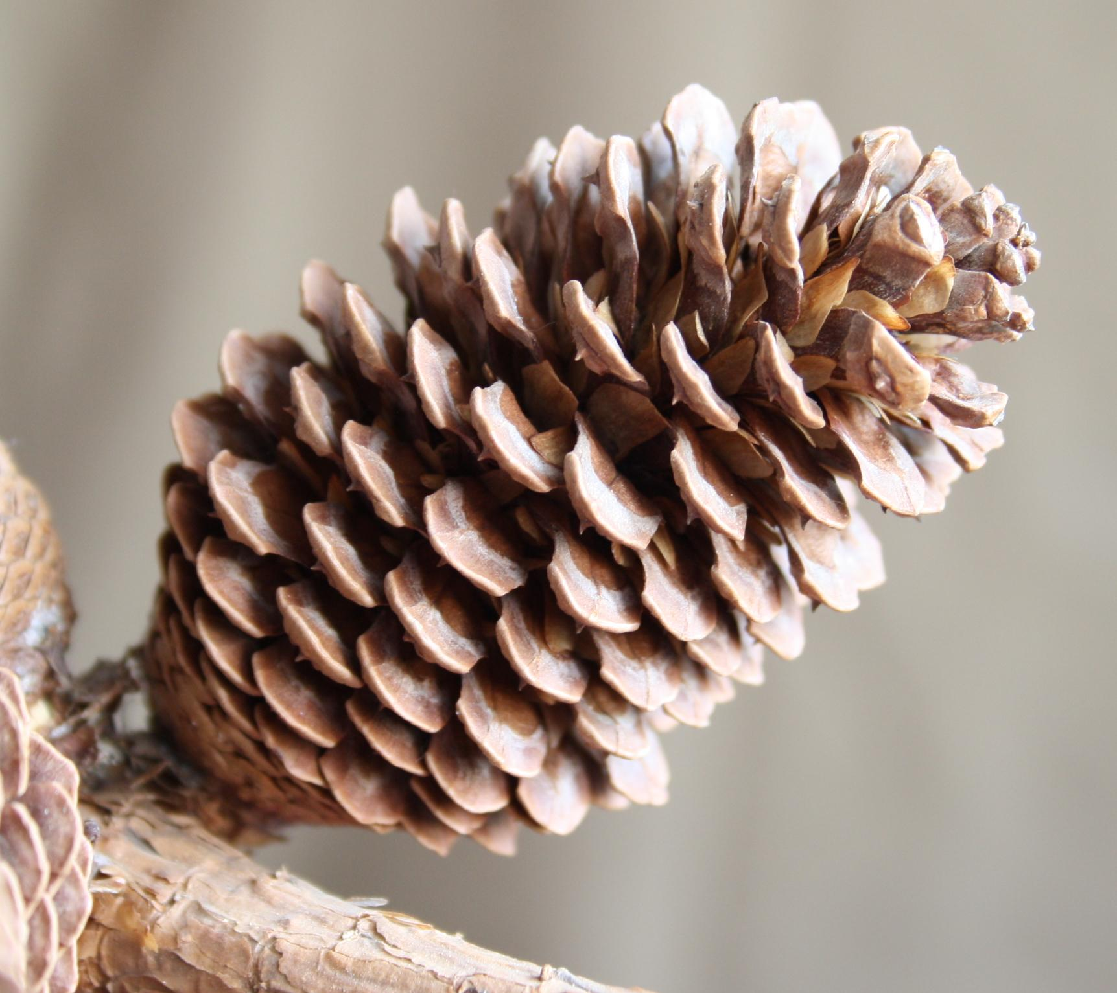
Why not use what the children have found and the pictures they have taken and drawn to make a ‘winter’ display with them in the classroom?

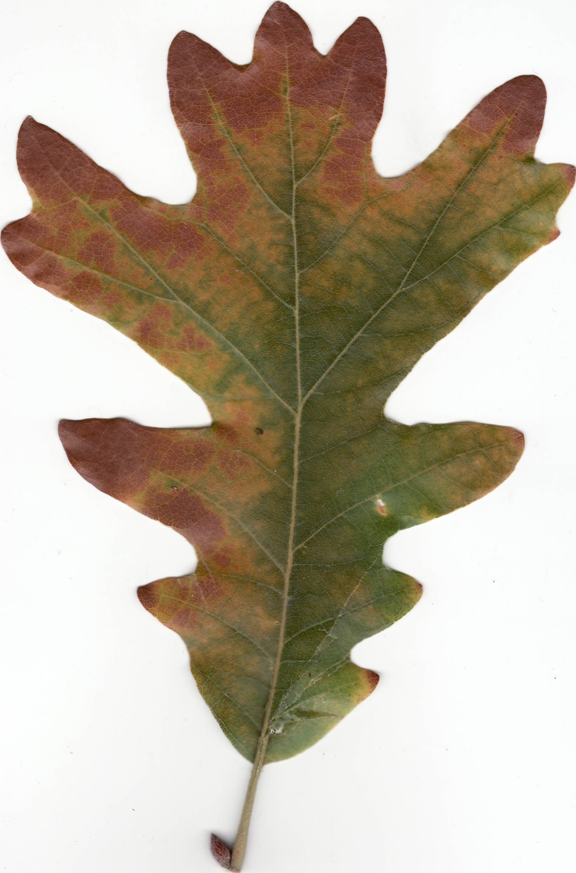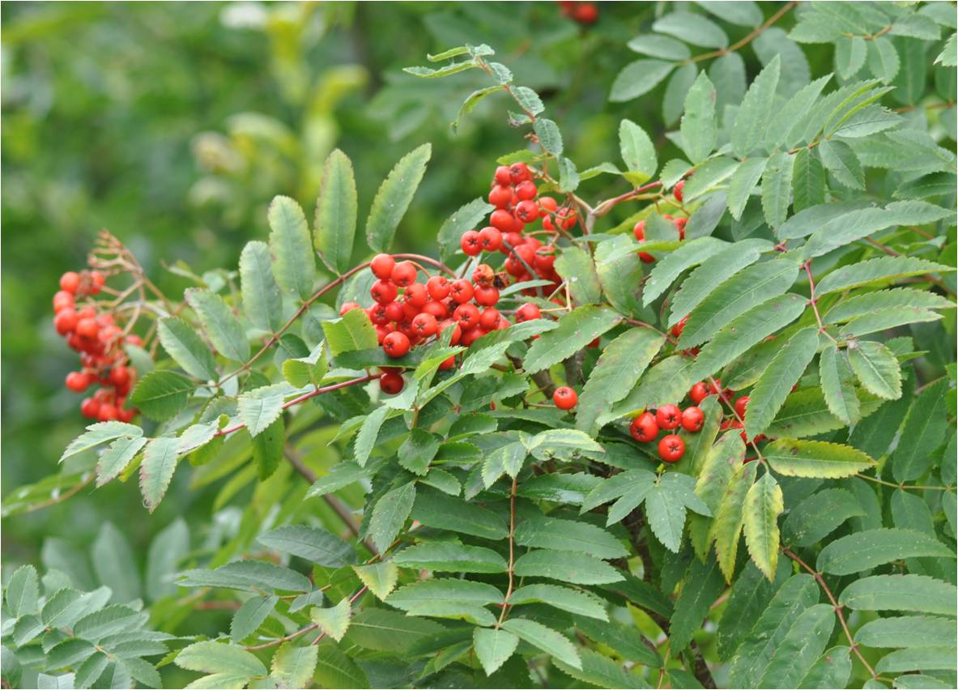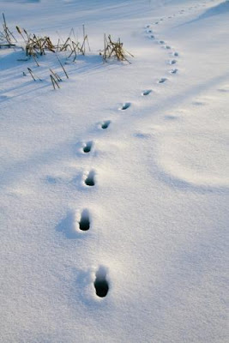
We’d love to see pictures of your winter display, please send us pictures to hello@tutti-frutti.org.uk
Boy Wolf Winter Walk

Making snowy wool pictures

You will need
- Some wool fleece in different colours.
- paper or card
- glue
- two hairbrushes if you want to card your wool!

You can buy wool fleece at craft shops. Before fleece is spun (to make wool) it needs to be ‘carded’ to make it smooth.
Professionals do this with big brushes with wire bristles but you could do it with two old hairbrushes.
Hold them one on top of the other with the wool in between and pull in opposite directions,
Like this

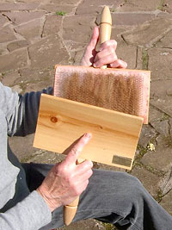
When our creative team were thinking of how the stage for the show might look they made this wool felt picture

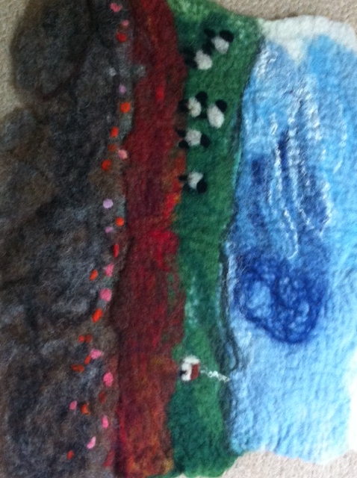
What will you include in your picture? What do you think you would see on Silas’s mountain? Trees, snow, sheep a wolf?!
Why don’t you use different materials for the various elements of the picture such as cardboard, foil, fleece and twigs. If you don’t have fleece you could use cotton wool.

We’d love to see your snowy wool pictures, please send us your pictures to hello@tuttifrutti.org.uk
Snowy Wool Pictures

–––––––––
Making snowy wool pictures

You will need:
- A clean empty jam jar
- PVA Glue
- Tissue paper, fabric, doilies or transparent sweet wrappers (anything see through you can stick to your jar!)
- A tea light (real or LED for safety)

Winter Jam Jar Lanterns

When it’s dark and cold outside why not make a winter jam jar lantern to light up your room or the garden?
Use an empty (clean!) jam jar and some materials to stick on it (see through materials like tissue paper, doilies, lace or clear sweet wrappers work best.)
Create a winter scene - you could include mountains, the night sky or snowy trees. Alternatively you could choose a shape you like (a snowflake or a tree) and create a pattern with that shape.

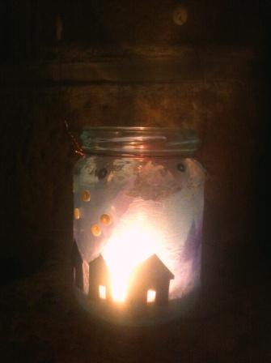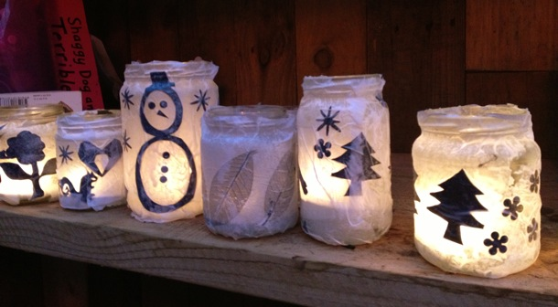
We’d love to see your winter lantern, please send us a picture of it to
hello@tutti-frutti.org.uk
Winter lanterns

